ECOMMERCE INSTRUCTIONS
COMPLETING LOG IN AND PASSWORD REGISTRATION
- Access our city website at www.mtsterlingil.com
- Choose VIEW/PAY eBILLS , yellow button
- Next choose the Register button
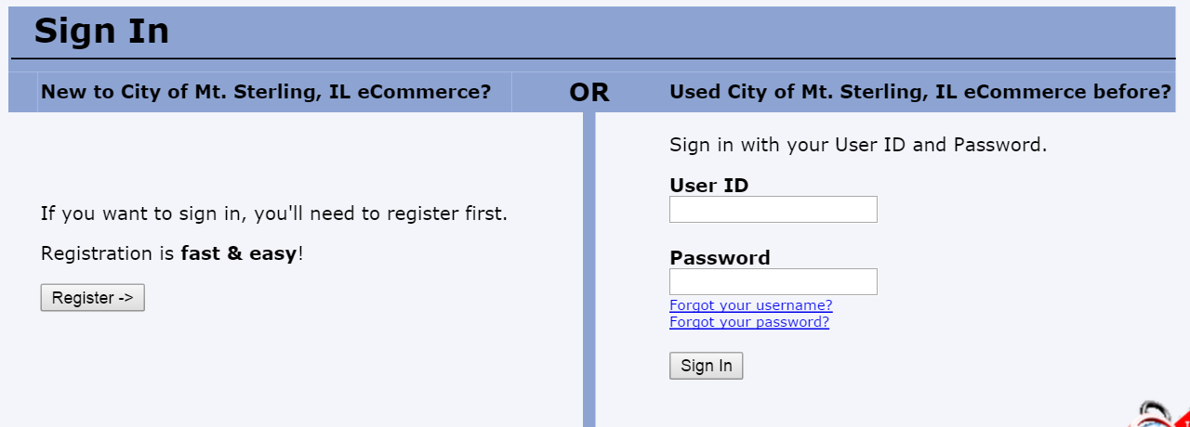

- You will create your eCommerce ID (do not use your email) and choose a password.
Follow the instructions to complete your registration. Upon completing your registration, you are signed up for eBilling. You will no longer receive a paper bill in the mail. To ensure all emails get to your inbox, add us to your whitelist.
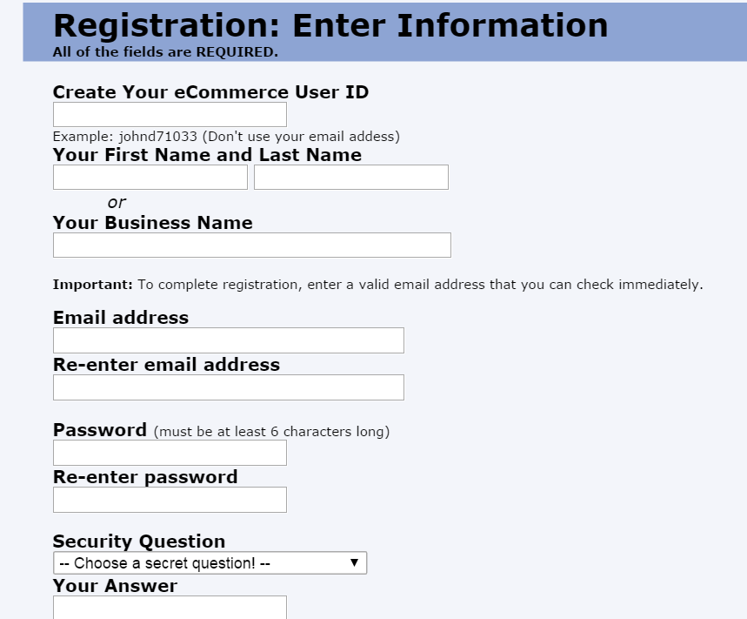
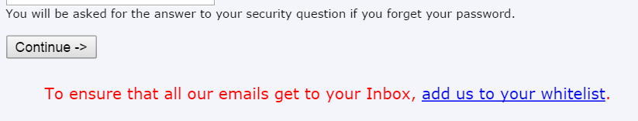

- Return to the sign on screen and sign on using your newly created User ID and password.

- Now you are ready to choose “View & Pay Bills” button.
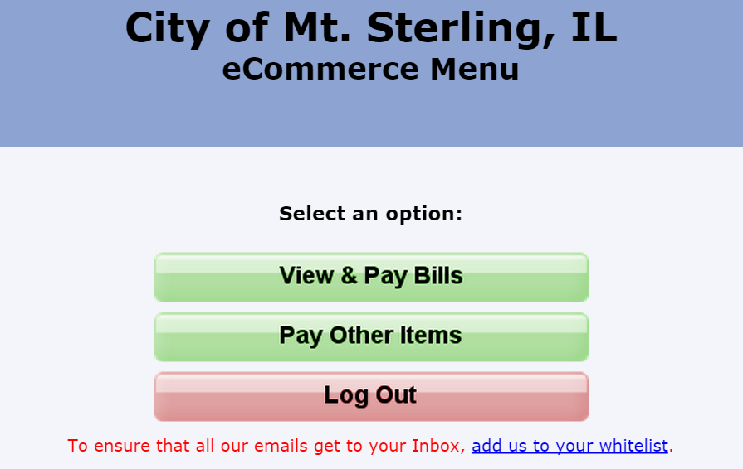

- You will need to add your account. This is only required the first time unless you have more than one account you wish to pay online. Choose “Add an Account”.
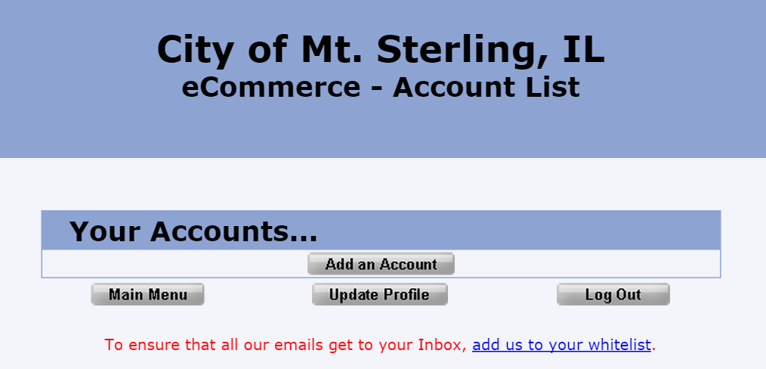

- The “Select Bill Type” will always remain “Water Bill”.
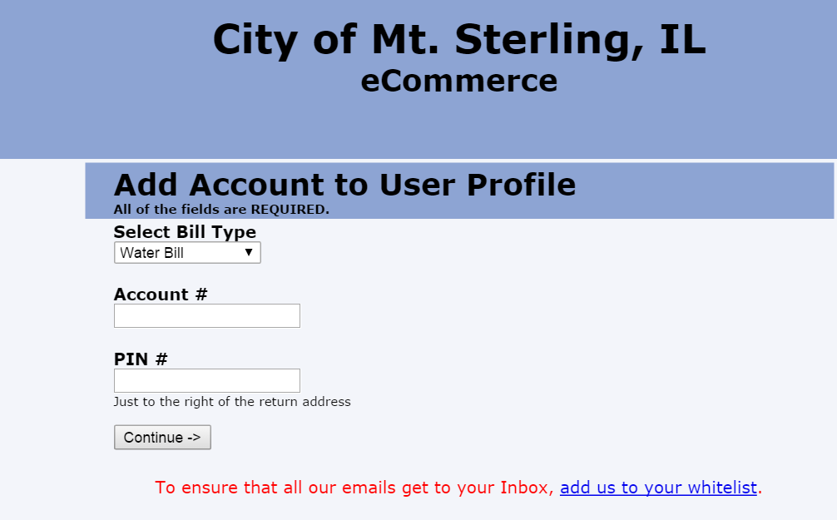

- Locate your account number from your water bill statement. It should be in the left hand corner below the City of Mt. Sterling address. Enter including all leading zeros and dash, in Account # box.

- Find your 5 digit PIN in the top middle, just to the right of City of Mt. Sterling. This is a unique number for each customer. Enter in the PIN # box and choose “Continue”.
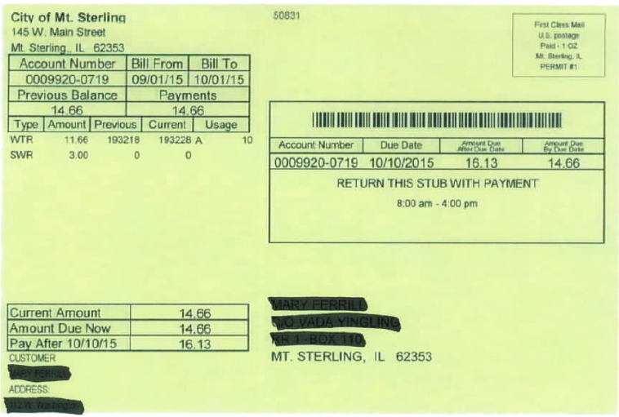

- Please read the “eCommerce Terms & Conditions” and confirm by entering your last 4 digits of your Social Security Number (SSN). Then choose “I Agree” or “I Don’t Agree”. You must choose “I Agree” to continue with your account setup. If you do not agree with these terms, you may not use the eCommerce option.
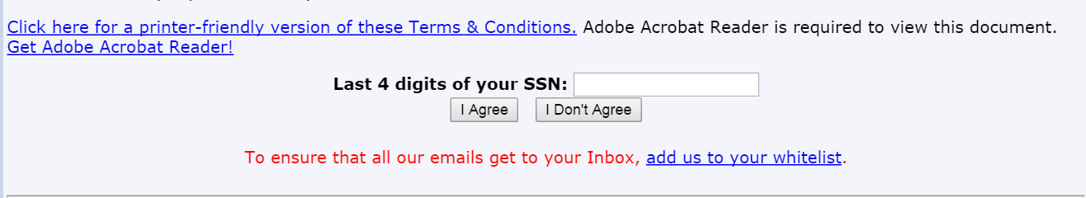

- After choosing “I Agree” with the terms & conditions, you will be returned to this screen with the message that “Your account has been added to your user profile, but will not show up on your Account List until it has been verified. An email will be sent to you when the account has been verified”.
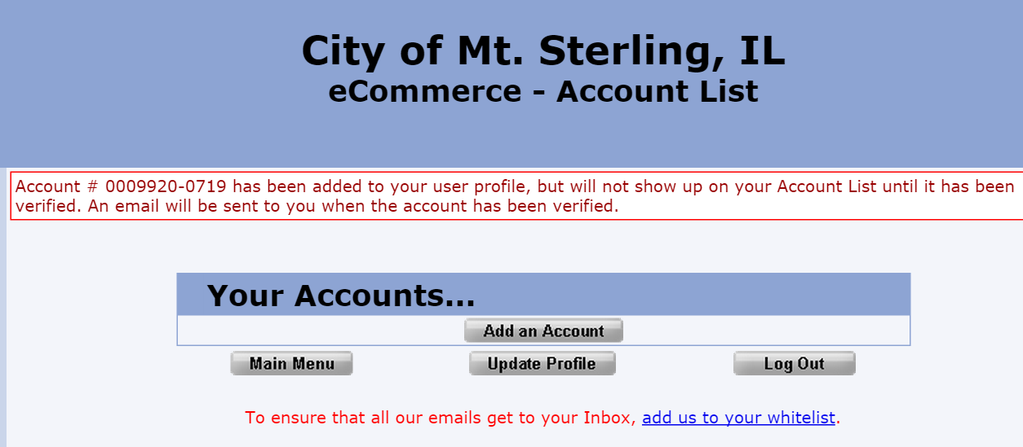

- Go to your email account and open the verification email (this takes a while for email to be sent) and follow the instructions. You have completed your log in and password registration.

USING EPAY AND PAYPAL
- Sign in to eCommerce by pressing the VIEW/PAY eBILLS, yellow button.
- Enter your User ID then your Password and press “Sign In” button.

- Choose the green “VIEW/PAY eBILLS” button
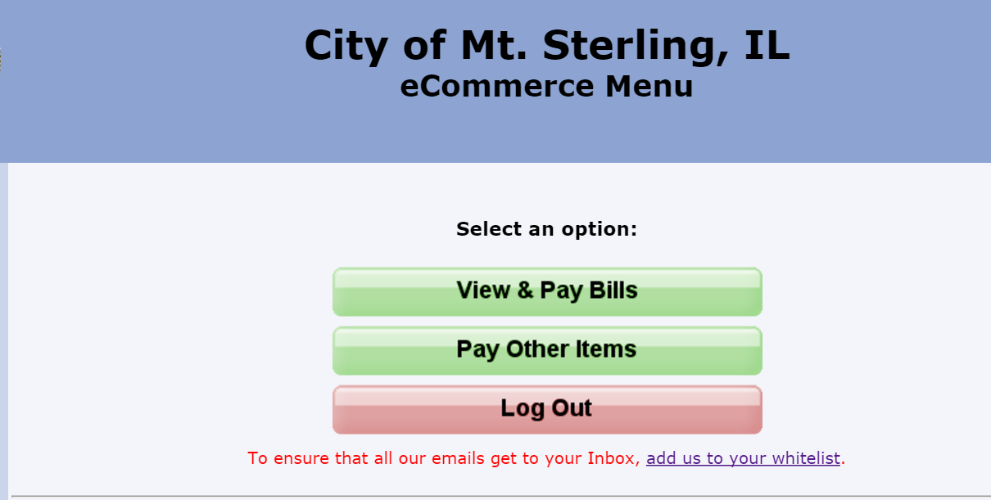

- This screen displays your account number and balance. You can pay from this screen by pressing the
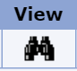 “View” button with the black binoculars.
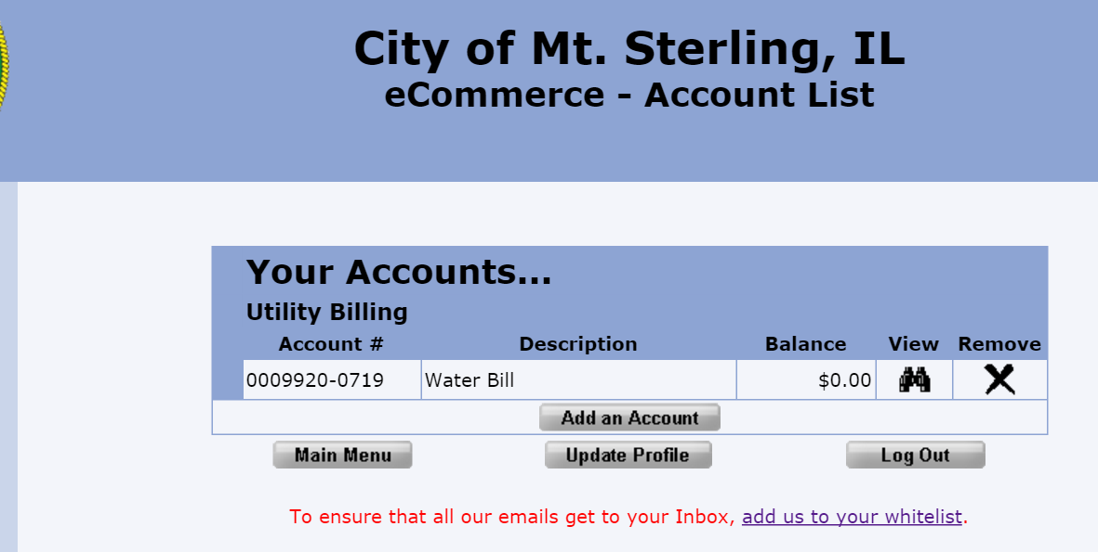
- From this screen, you can choose the “Pay Now Button.” You can also choose “Account List” if you have more than one account registered with eCommerce.
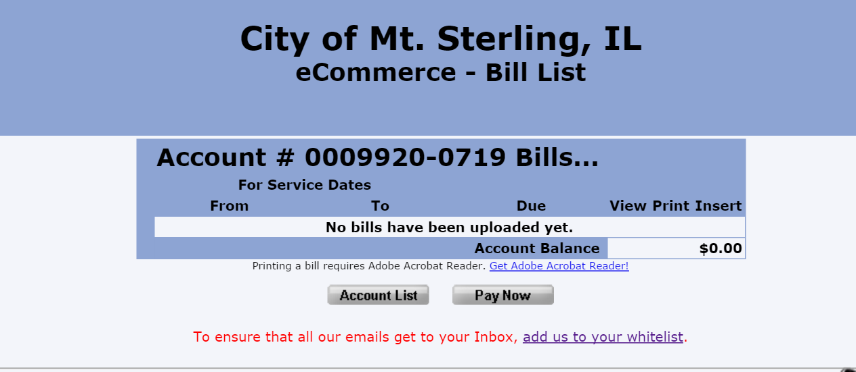

- Choosing “Pay Now Button” takes you to this screen. Choose your payment type and check the box accepting the convenience fee. Choose the “Make Payment” button and you’ll receive confirmation of your payment.
